SIMATS ENGINEERING ASSESSMENT TOOL 1
COURSE NAME: Ethical Hacking
COURSE CODE: ITA14
COURSE OUTCOME COVERED
CO2: Foot printing Tools: Conducting Competitive Intelligence, DNS Zone Transfers, Introduction to Social Engineering: Social Engineering Attacks and Countermeasures. (BT3)
Code of Conduct: I Kishore P (192511046) certify that this submission is my original work and that I have adhered to the guidelines specified for this assessment. I understand that any violation of academic integrity rules will result in disciplinary action.
- A security analyst performed a network scan on the target 192.168.1.10 using the Nmap tool. The report identified several open ports, including HTTP (80), SSH (22), and MySQL (3306), along with the operating system and service versions. Analyze the report and explain the security risks associated with the identified services. Discuss how an attacker could exploit these services and recommend suitable security measures to protect the target system. (20 Marks)
Commands :

nmap scanme.nmap.org

nmap -sV scanme.nmap.org

sudo nmap -O scanme.nmap.org

sudo nmap -A scanme.nmap.org

1. Analysis of Identified Services & Technical Security Risks
- HTTP (Port 80):
  - Risk: HTTP transfers cleartext data over the network without cryptographic protection.
  - Exploitation Vector: Attackers on the local network path can execute Man-in-the-Middle (MitM) packet sniffing to capture sensitive user credentials or session cookies. Additionally, unpatched web application frameworks hosted on Port 80 are targetable via Cross-Site Scripting (XSS) or SQL Injection (SQLi) attacks.
- SSH (Port 22):
  - Risk: Direct remote command-line access point to the underlying operating system.
  - Exploitation Vector: Exposed to automated password brute-forcing, dictionary attacks, and credential-stuffing scripts. If outdated SSH protocol versions or weak cipher suites are enabled, attackers can exploit known remote code execution (RCE) vulnerabilities to gain shell access.
- MySQL Database (Port 3306):
  - Risk: Direct external network exposure of the primary database service storing organizational data.
  - Exploitation Vector: Threat actors can launch direct automated authentication brute-force attacks against database accounts (e.g., root). If successful, attackers can exfiltrate sensitive data, drop database tables, or leverage elevated privilege exploits to execute system commands on the host server.

2. Recommended Security Measures & Mitigation Strategies
- HTTP Security Hardening:
  - Implement Transport Layer Security (TLS 1.3/SSL) and force all HTTP traffic to redirect to HTTPS (Port 443).
  - Enforce HTTP Strict Transport Security (HSTS) headers to prevent protocol downgrade attacks.
- SSH Security Hardening:
  - Disable root remote login (PermitRootLogin no) and enforce asymmetric SSH key-based authentication while disabling password authentication (PasswordAuthentication no).
  - Restrict SSH access behind a Secure VPN or IP whitelist via local firewall rules (iptables / ufw).
- MySQL Security Hardening:
  - Reconfigure the MySQL service daemon to bind strictly to the loopback interface (bind-address = 127.0.0.1) so it cannot accept remote connections over external interfaces.
  - Enforce the principle of least privilege for database users and ensure all default database accounts/test tables are removed.
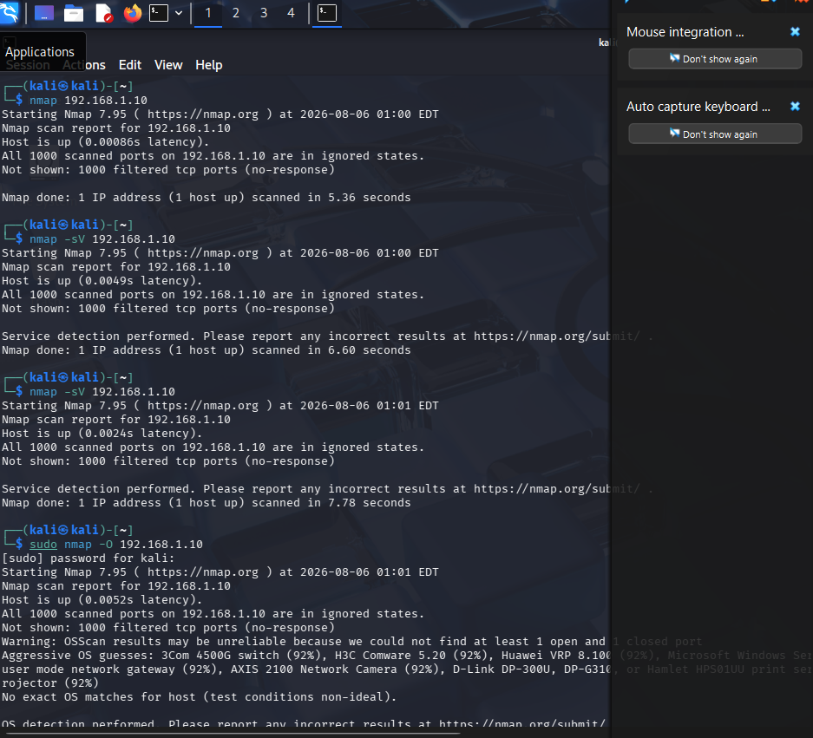
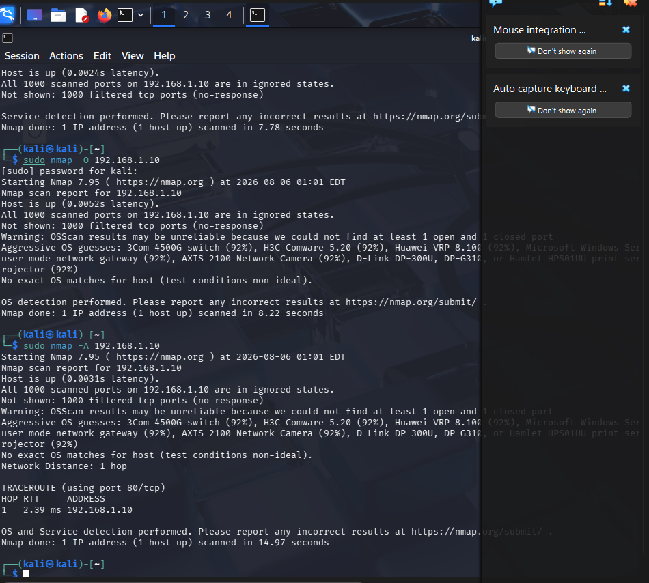

- A phishing awareness campaign was conducted for employees of ABC Technologies Pvt. Ltd. using the GoPhish tool. The report indicates that 40% of employees clicked the phishing link, 20% entered their login credentials, and several users downloaded a malicious attachment. Analyze the report and identify the security weaknesses demonstrated by the employees. Recommend suitable user awareness programs, email security controls, and organizational policies to reduce the risk of successful social engineering attacks.(20 Mark).

Procedure :
- Created Email Template.
- Created Landing Page.
- Configured Mailtrap SMTP.
- Created User Group.
- Created Campaign.
- Send phishing emails.
- Viewed campaign statistics.
Email Security Controls :
- Enable Spam Filtering.
- Use Email Gateways.
- Configure SPF (Sender Policy Framework).
- Configure DKIM (DomainKeys Identified Mail).
- Configure DMARC (Domain-based Message Authentication, Reporting, and Conformance).
- Block dangerous attachments.
- Scan email attachments using antivirus software.
- Enable URL filtering.

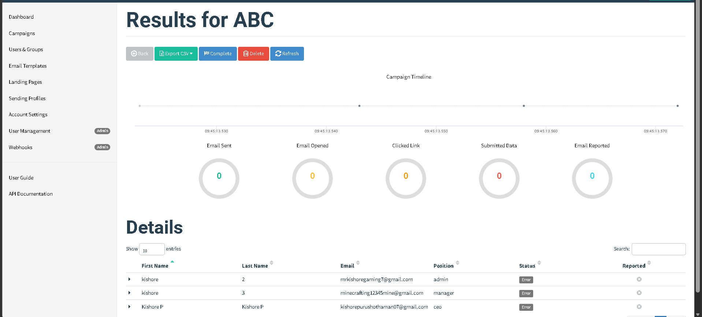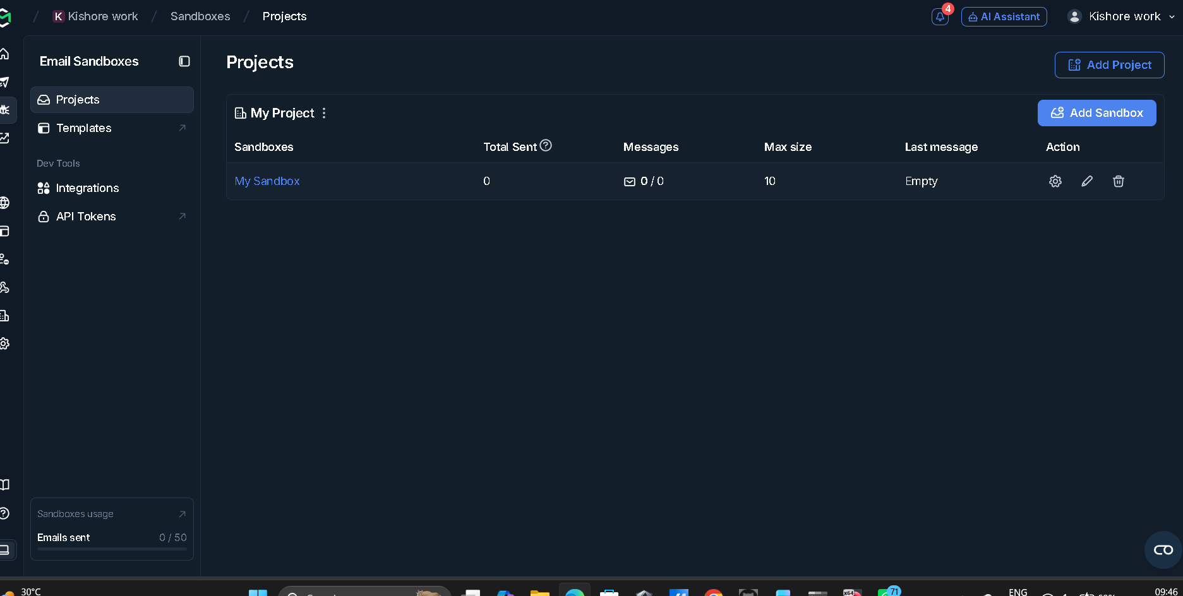

- A DNS assessment report generated using the Dig tool shows that the organization's DNS server permits a successful DNS Zone Transfer (AXFR), exposing internal hostnames, mail servers, and DNS records. Analyze the report and explain the security implications of the exposed information. Discuss how attackers could exploit these findings and recommend best practices to secure the DNS infrastructure..(10 Marks)
Command :
dig AXFR zonetransfer.me @nsztm1.digi.ninja
Observation :
- DNS Zone Transfer succeeded.
- Internal DNS records were exposed.
- Mail server records were visible.
- Multiple hostnames and IP addresses were disclosed.
Possible Attacks :
An attacker can use the exposed information to:
- Perform reconnaissance.
- Scan exposed servers.
- Launch phishing attacks.
- Target mail servers.
- Exploit vulnerable web servers.
- Attempt brute-force attacks on exposed services.
- Prepare for advanced cyberattacks.
To Secure DNS Infrastructure :
- Disable DNS Zone Transfer for unauthorized users.
- Allow AXFR only between trusted DNS servers.
- Configure Access Control Lists (ACLs).
- Enable DNSSEC to protect DNS integrity.
- Regularly update DNS software.
- Monitor DNS logs.
- Remove unnecessary DNS records.
- Perform regular DNS security audits.
